Invites applications for the position of:
District Manager
Opening Date: February 16, 2023
Closing Date: March 17, 2023

The District Manager serves as the district’s chief executive officer and reports to a five-member elected board of directors.

Location: Boardman, Oregon
Application Deadline: March 17, 2023
Pay and Benefits:
Starting Salary Range: $100,000.00 - $110,000.00 annually
Benefits include health insurance (medical, dental, and vision), 7% District contribution to retirement program, district provided cellphone for work related activity, 12 vacation days, 9 holidays
Desirable Starting Date: May 1, 2023
Position Summary:
Boardman Park and Recreation District is currently recruiting qualified applicants to fill the position of District Manager. Serving as the district’s chief executive officer, the district manager reports to a five-member elected board of directors.

The district is looking to hire a person who, through collaborative leadership, board, staff, and customer engagement, and outstanding management and administrative skills will enhance the district’s ability to deliver parks and recreation services efficiently and effectively. Along with strong administrative skills, the district manager must be able supervise and evaluate four managers who supervise approximately 25 employees. With the assistance of department managers, the district manager must be able to develop and manage a district-wide budget and keep the board apprised of any irregularities. The district manager is also expected to continually look for opportunities to raise additional funds through grants and other means that will enhance the park system, recreation facilities and/or programs. Additionally, the district manager must have exceptional communication skills with the ability to address issues calmly, tactfully, and proactively.

About the District
Boardman Park & Recreation District was formed in 1967 as an Oregon Special District to lease approximately 143 acres from the US Corps of Engineers for the purpose of maintaining a marina and community park with camping sites. The marina park includes a 63-space recreational vehicle campground and a 28-space moorage dock. Both facilities operate year-round. The district significantly expanded its services in 2017 with the opening of the 43,000 square foot Boardman Pool and Recreation Center. For more information about the district please visit our website at: www.boardmanparkandrec.com.

A five-member elected board of directors governs the district. Currently, the five members are Krista Price as Board Chair, George Shimer as Vice Chair, David Boor as Secretary/Treasurer, John Christy, and Norma Ayala. To help support district operations, the district levies property taxes and is funded by a permanent tax rate of $0.2989 per $1,000 of value for those property owners within the district, which encompasses all the City of Boardman and some outlying areas. There are approximately 1,200 voters within the district.

The Ideal Candidate –
The individual appointed to this position will possess well-developed business management, administrative and leadership skills. They will recognize that policy is set by the Board of Directors and will provide an open and direct flow of information to assist in the formulation of District policies. The ideal candidate will also:
- Be an excellent communicator and representative of the district. Bilingual in English/Spanish preferred.
- Act as a catalyst and “front” person who can help the board of directors, staff and the community create a clear vision for parks and recreation in the community.
- Promote recreation ideas and concepts and sell them in the broader community.
- Maintain responsibility for establishing and nurturing successful press relations.
- Be able to secure grants and other funding sources to assist with facility and program improvements and/or development.
- Prepare and track the annual District Budget.
- Build and maintain collaborative partnerships with public agencies, private industry, and non-profit organizations.

To review the full job announcement and job description and to complete the application please see this link: https://www.sdao.com/classifieds. To be considered as a candidate, please submit a completed and signed application, resume, and cover letter to the address or email listed below. Electronic submission is preferred.

Attn. Shanta Carter
Boardman Park and Recreation District – District Manager
Special Districts Association of Oregon
PO Box 23879
Tigard, Oregon 97281
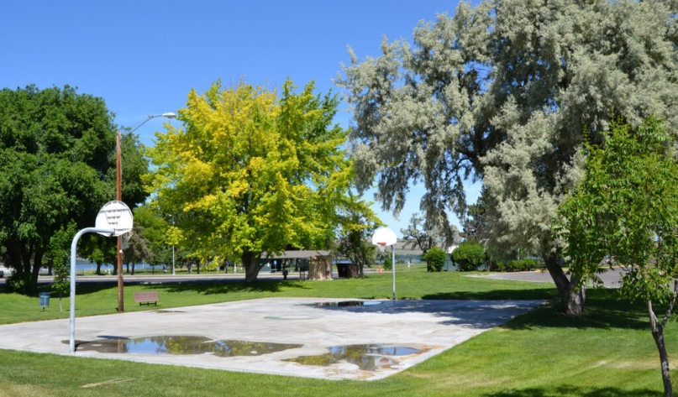
Email: sdaoconsultingservices@sdao.com

