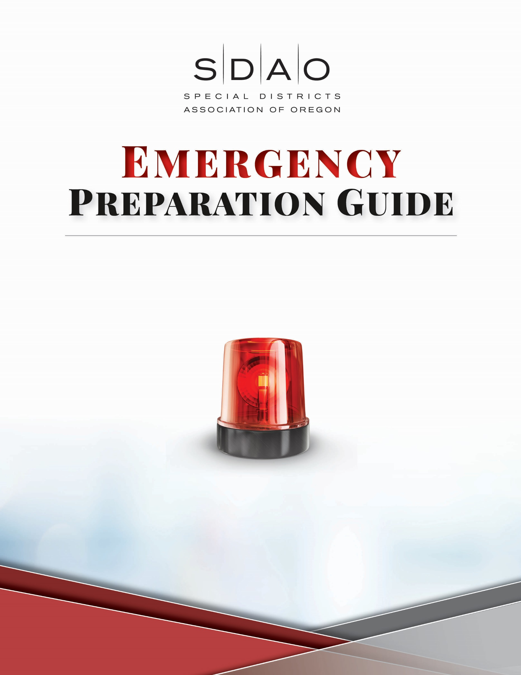
(Enter Special District Name)
(Enter Address Line 1)
(Enter Address Line 2)
(Enter Special District Name)
(Enter Address Line 1)
(Enter Address Line 2)

Contents of this Profile
- Emergency Action Checklist
- Advanced Warning and Emergency Contacts
- Emergency Contacts
- Main Utility Information (Shut Off Locations)
- Primary Contact Information (Work Authorization Contact)
- Insurance Contact Information
- Miscellaneous Contact Information
- Property Overview
- Building Access Information
- Evacuation maps

Emergency Action Checklist
Below is an action list of what to do in the event of a fire, water damage event, or emergency that will help keep employees safe and help reduce business interruption.
Advanced Warning: Be alert and stay informed
Always think safety first
Stop the source of damage
Notify emergency contacts
Call your restoration contractor
Notify key contacts
Secure the property
Take photos of damaged property
Write summary of event/documentation

Advanced Warning
Listen to local weather, Red Cross and county emergency management for severe weather alerts.
- Turn off all the main utilities or valves
- Disconnect electrical equipment and appliances
- Move vehicles from low lying areas
- Review evacuation floor plans
- Board up windows prior to forecasted high winds

Emergency Contacts
Main HR Contact
Name: (Enter name) Phone: (Enter phone #) Emergency Phone: (Enter phone #)
Email: (Enter email)

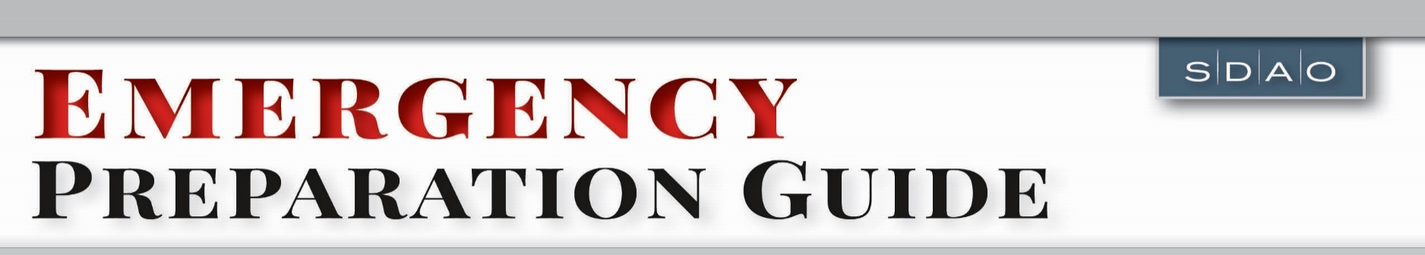
Emergency Contacts
Emergency Non-Emergency Local Direct Line
Local Police Department 911 (XXX-XXX-XXXX) (XXX-XXX-XXXX)
Local Fire and Rescue 911 (XXX-XXX-XXXX) (XXX-XXX-XXXX)

Emergency Non-Emergency Local Direct Line
Local Hospital 911 (XXX-XXX-XXXX) (XXX-XXX-XXXX)
On Call Security Services (XXX-XXX-XXXX) (XXX-XXX-XXXX)
Business Continuity Contacts (XXX-XXX-XXXX) (XXX-XXX-XXXX)
Generator Service Company (XXX-XXX-XXXX) (XXX-XXX-XXXX)

Utility Contact and Shut Off
Electric Company Name Phone Number Account Number
(Enter company name here) (Enter phone # here) (Enter acct. # here)
Shut off location -
Description of location -
Is a key needed for access?

(Add a photo of the shut-off below)

Gas Company Name Phone Number Account Number
(Enter company name here) (Enter phone # here) (Enter acct. # here)
Shut off location -
Description of location -
Is a key needed for access?

(Add a photo of the shut-off below)

Water Company Name Phone Number Account Number
(Enter company name here) (Enter phone # here) (Enter acct. # here)
Shut off location -
Description of location -
Is a key needed for access?

(Add a photo of the shut-off below)

Alarm Company Name Phone Number Account Number
(Enter company name here) (Enter phone # here) (Enter acct. # here)
Shut off location -
Description of location -
Is a key needed for access?

(Add a photo of the shut-off below)

Sprinkler Company Name Phone Number Account Number
(Enter company name here) (Enter phone # here) (Enter acct. # here)
Shut off location -
Description of location -
Is a key needed for access?

(Add a photo of the shut-off below)

Main IT Contact
Name: (Enter name here) Phone: (Enter phone #) Emergency Phone: (Enter phone #)
Email: (Enter email here)
Shut off location -
Description of location -
Is a key needed for access?

(Add a photo of the shut-off below)

Primary Contacts
Name |  | Title | Phone | Emerg. Phone
Building Owner  (Enter first name here)  (Enter last name here) | Name of District  (Enter district name here)  (Enter district name Line 2) | (Building Owner) | (xxx-xxx-xxxx) | (xxx-xxx-xxxx)
Email Address: (Enter email here)
Building Contact  (Enter first name here)  (Enter last name here) | Company/Dist. Name  (Company name here)  (Company name here Line 2) | (Maintenance Supervisor) | (xxx-xxx-xxxx) | (xxx-xxx-xxxx)
Email Address: (Enter email here)
Work Authorization  (Enter first name here)  (Enter last name here) | Company/Dist. Name  (Company name here)  (Company name here Line 2) | (Director of  Facilities) | (xxx-xxx-xxxx) | (xxx-xxx-xxxx)
Email Address:
Maintenance  (Enter first name here)  (Enter last name here) | Company/Dist. Name  (Company name here)  (Company name here Line 2) | (Maintenance Supervisor) | (xxx-xxx-xxxx) | (xxx-xxx-xxxx)
Email Address: (Enter email here)
Risk Manager  (Enter first name here)  (Enter last name here) | Company/Dist. Name  (Company name here)  (Company name here Line 2) | (Director of Facilities) | (xxx-xxx-xxxx) | (xxx-xxx-xxxx)
Email Address: (Enter email here)
Insurance Company Information
Broker Name & Company Phone Number Policy Number
(Enter broker name here) (Enter phone # here) (Enter policy # here)
Insurance Carrier
SDIS (Special Districts Insurance Services) 1-800-305-1736 or 503-670-7066

(Add an aerial photo of property from Google Earth)

Other Contacts
Internet Provider Phone Number Account Number
(Enter company name) (Enter phone #) (Enter acct. #)
HVAC Phone Number Account Number
(Enter company name) (Enter phone #) (Enter acct. #)
Flooring Phone Number Account Number
(Enter company name) (Enter phone #) (Enter acct. #)
Plumber Phone Number Account Number
(Enter company name) (Enter phone #) (Enter acct. #)
Elevator Company Phone Number Account Number
(Enter company name) (Enter phone #) (Enter acct. #)
Phone Company Phone Number Account Number
(Enter company name) (Enter phone #) (Enter acct. #)
Electrician Phone Number Account Number
(Enter company name) (Enter phone #) (Enter acct. #)
Mechanic Phone Number Account Number
(Enter name and company name) (Enter phone #) (Enter acct. #)

Property Overview
(Add photo of the building below)

Building Address: (Enter building address here)
Directions to Property: (Enter directions here)
Year Built: (Enter year here) Renovations – yes or no If yes, what year?
Hazardous Materials: (List materials here)
Type: (Enter type of materials here)
Location: (Enter location of materials here)
Total Square Footage of Building: (Enter xxxx sq. ft. here)

Floor | Primary Use | Apprx. Sq. Ft. | Type of Flooring
(Enter Floor #) | (Describe Use) | (Enter Sq ft.) | (Enter floor type)
(Enter Floor #) | (Describe Use) | (Enter Sq ft.) | (Enter floor type)

Blueprints Available - yes or no If yes, where are they located?
Supplemental Generator Power - yes or no If yes, where is it located?
Fuel - yes or no If yes, where is it located?
Building Access
Knox Box: (Enter location here)
Security Access: (Enter location here)
Preferred Access Point: (Enter location here)
Elevator Access: (Enter location here)
Stairway Access for Service: (Enter location here)

Evacuation Maps
Fire Evacuation Map
(Add photo below)

Fire Extinguisher Map
(Add photo below)

Tsunami Evacuation Map
(Add photo below)

