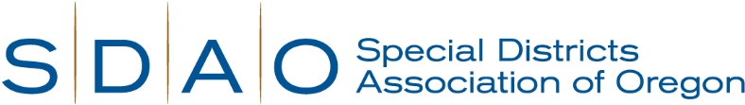

Application Instructions for Risk Management Consultant with SDAO
For questions, including hiring salary information, please contact hr@sdao.com

Special Districts Association of Oregon is in search of their next

Risk Management Consultant

Location: Based out of Salem, OR with travel required

The mission of Special Districts Association of Oregon is to assist special service districts in providing cost-effective and efficient public services to the people of Oregon. This position with SDAO offers an exceptional benefits package, paid holidays, sick and vacation accruals, and much more!
If you are interested in applying for the position of Risk Management Consultant, please provide the following:
- A current resume
- A cover letter that clearly outlines how your knowledge, skills and abilities meet or exceed the minimum requirements for the position.
- Completed employment application.
Please provide your full application packet to hr@sdao.com.
Open until filled with first consideration given to submissions received by May 26, 2023.
The start date for this position will be July 10, 2023.

