LaGrande Rural Fire District

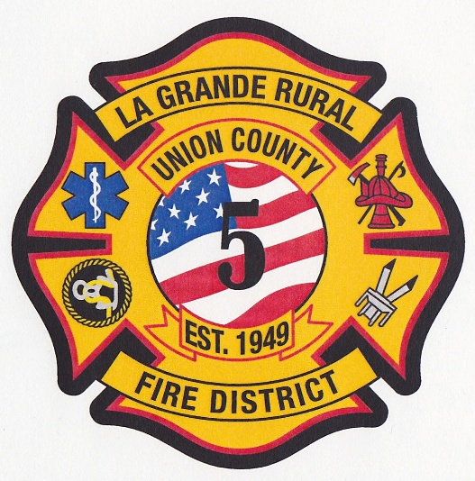
Fire Chief
$80,000- $100,00
Plus, competitive benefit package

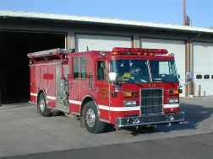
Apply by February 2, 2026
Fire Chief
LaGrande Rural Fire District
Full-Time Position
Salary Range: $80,000-$100,000
Benefits: Comprehensive benefit programs that includes retirement, family health insurance, life insurance, vacation, and holidays.
The District

La Grande Rural Fire Protection District (LGRFPD), commonly known as Island City Fire Department, has been serving Island City, Oregon and the surrounding area since 1949. It provides fire, emergency medical services (EMS), and rescue services to approximately 6,000 residents. district covers approximately135 square miles (nearly 100,000 acres), ranging from large industrial complexes, such as Boise Cascade Particle Board Plant and the Union County Airport, to residential areas and farm and ranch lands.

La Grande Fire District is located on the western margin of the Grande Ronde Valley that is bounded by the Blue Mountains and Wallowa Mountains. These mountains and the Grande Ronde River offer abundance of natural resources and wildlife. Initially a logging and agriculture area, it has become a sports and recreation destination.

The Position

The Fire Chief is the chief administrator and CEO of the Fire District and is responsible for the total supervision and operation of the Fire District. Responsibilities might include developing plans for fire protection, water systems, station locations, disaster preparedness, and communications.

The Fire Chief works under the supervision of the Board of Directors of the Fire District, but independently applies leadership, fire prevention, firefighting techniques, and emergency medical aid and procedures. The Fire Chief must demonstrate the highest standards of integrity, ethics, and leadership and must possess keen judgment, innovation, and foresight.

The Ideal Candidate
The ideal candidate will possess the following attributes at a minimum:
- Excellent leadership, management and team building skills including strategic planning, personnel management, project management, problem analysis, delegation, decision making, critical thinking, judgment, conflict resolution, adaptability/flexibility, delegation, stress tolerance and time management.
- Strong presentation, oral and written communication skills with the ability to communicate and present complex ideas and information, and apply appropriate communication techniques, to various audiences.
- Strong negotiation and partnering skills with the ability to establish and maintain cooperative and effective working relationships with the Board of Directors, command staff, assigned personnel, labor representatives, other District volunteers and employees, various professional, civic and government officials, and the general public under both regular business and adverse/emergency conditions.
- Ability to investigate, gather and evaluate information, identify problems, and makes logical decisions; project consequences of actions; testify in court in relation to findings and opinions.
- Ability to work independently and effectively under minimal supervision.
- Ability to work under pressure, consistently meet timelines and project/program objectives, and adjust to changing priorities.
- Ability to take personal accountability for one’s actions and responsibilities.

Education, Experience, and Certification/Licensure:

REQUIREMENTS

- Minimum of 5 years progressive fire service experience, with 2 years as a company officer or higher

- Valid Oregon driver’s license that is insurable by the district’s insurance carrier.

- Must be able to meet the physical requirements of the position.
- Successfully pass districts alcohol, drug and financial/criminal background evaluation
- Must establish residency within the Fire District boundaries, tome frame negotiable with Board.

Desirable Starting Date: April 16, 2025

To be considered please submit a letter of introduction, resume, and completed application by email or postal service to:
Attn. Shanta Carter C/O La Grande Rural Fire District Board of Directors
La Grande Rural Fire District Fire Chief Selection Process
Special Districts Association of Oregon
PO Box 23879
Tigard, Oregon 97281

Email: scarter@sdao.com

Application Deadline: February 2, 2026

