**STATE OF OREGON**

**Oregon Military Department**

**Office of Emergency Management**



**Hazard Mitigation Grant Program**

**A Handbook for Local Officials**

STATE OF OREGON

Hazard Mitigation Grant Program Handbook

**Table of Contents (click the arrow to the left of a section to open, Ctrl+Click to go to a section in the document from the Table of contents)**

1. INTRODUCTION 6

2. PURPOSE OF THIS HANDBOOK 7

3. HAZARD MITIGATION GRANT PROGRAM FUNDING TYPES 8

3.1 Planning 8

3.2 Project 8

3.3 The 5% Initiative 8

3.4 Advance Assistance 9

4. COST SHARE 10

4.1 What can be used for Cost Sharing? 10

5. MULTI-HAZARD MITIGATION PROJECTS 11

5.1 Eligible Applicants Chart 11

5.2 Eligible Hazard Mitigation Related Activities (Includes Chart) 11

6. KEY DEFINITIONS & CONCEPTS 12

6.1 Applicant/State 12

6.2 Subapplicant 12

6.3 Funds Availability 12

6.4 Letter of Intent 12

6.5 Sub-Grant Application 12

6.6 Cost Sharing 13

6.7 Bona Fide Need Rule 13

6.8 Duplication of Programs 13

7. GETTING THE SUBAPPLICANT’S PROPOSAL STARTED 15

7.1 Subapplicant Point of Contact 15

7.2 Duties Assigned to the Subapplicant 15

7.3 Keeping Potential Project Participants Informed 15

7.4 Budget Development 16

7.4.1 Pricing Guidance for New Plans and Plan Updates Chart 17

7.4.2 Factors that Affect the Budget – Program Income 18

7.4.3 Pre-Award Costs 18

8. SCOPE OF WORK STATEMENT 19

9. MANAGING HMGP SUBAPPLICATIONS – PRE-APPROVAL 21

10. MANAGING AN APPROVED HMGP PROJECT 22

10.1 The Applicant (OEM) Notifies Subapplicant of HMGP Proposals Approval by FEMA 22

10.2 Application for Federal Assistance, Grant Agreement and Certifications 22

10.3 Fiscal Requirements 22

10.3.1 Procedures for Completing and Submitting an RFR Form 23

10.4 Rounding to Whole Dollar 23

10.5 Certification & Authorization 23

10.6 Scope of Work 23

10.7 Activation of Subapplicant Project Support Systems 24

10.8 Bidding Out Work 24

10.9 Cost Over Runs and Under Runs 24

10.10 Quarterly Reporting 25

11. PROJECT CLOSEOUT 26

11.1 Closeout Request 26

11.2 Record Retention 26

11.3 Single Audit Act 26

11.4 Grant Compliance 27

12. ELIGIBLE ACTIVITIES 28

12.1 Property Acquisition and Structure Demolition 28

12.2 Property Acquisition and Structure Relocation 28

12.3 Structure Elevation 28

12.4 Mitigation Reconstruction 28

12.5 Dry Floodproofing 29

12.6 Localized Flood Risk Reduction Projects 29

12.7 Non-Localized Flood Risk Reduction Projects 29

12.8 Structural Retrofitting of Existing Buildings 29

12.9 Nonstructural Retrofitting of Existing Buildings and Facilities 30

12.10 Safe Room Construction 30

12.11 Wind Retrofit Projects 30

12.12 Soil Stabilization 30

12.13 Wildfire Mitigation 30

12.13.1 Creation of Defensible Space 30

12.13.2 Application of Ignition-Resistant Construction 30

12.13.3 Hazardous Fuels Reduction 30

12.14 Post-Disaster Code Enforcement 30

12.15 5% Initiative Projects 31

13. INELIGIBLE ACTIVITIES 32

13.1 HMA Grant Funds May NOT be Used for the Following Costs/Items 32

14. HMGP FORMS AND EXAMPLES 34

14.1 Pre-Application Form/Letter of Intent 34

14.1.1 Sub-Applicant Information *(required)* 34

14.1.2 Basic Eligibility *(required)* 34

14.1.3 Proposed Activity Type (select applicable item(s)) 34

14.1.4 Individual Property-Related Projects *(if applicable)* 34

14.1.5 Proposal (required) 35

14.2 Example SOW for a Planning Grant 36

14.2.1 Purpose 36

14.2.2 Plan Development Tasks 36

14.2.3 Task 1. Organize Planning Team and Conduct Outreach Activities 36

14.2.4 Task 2. Document the Planning Process 37

14.2.5 Task 3. Conduct a Risk Assessment 37

14.2.6 Task 4. Develop a Mitigation Strategy 37

14.2.7 Task 5. Submit and Adopt the Plan 38

14.2.8 Attachments 39

14.2.9 Project/costPlan Period of Performance (POP) 39

14.2.10 Sample Timeline 9 Month POP 40

14.2.11 Sample Timeline 12 Month POP 40

14.2.12 Sample Timeline 15 Month POP 41

14.2.1 Completing the HMGP Application 41

14.3 Example Advance Assistance Pre-Application/Letter of Intent 42

STATE OF OREGON

HAZARD MITIGATION GRANT PROGRAM

HANDBOOK FOR LOCAL JURISDICTIONS

# INTRODUCTION

Hazard mitigation is any sustained action taken to reduce or eliminate long-term risk to people and property from natural hazards and their effects. Therefore, hazard mitigation actions are measured in terms of long-term hazard risk reductions and, when possible, the goal of hazard mitigation should be the permanent elimination of negative consequences resulting from a hazard. It is important to differentiate hazard mitigation from other phases of emergency management. Preparedness, response and recovery measures address the needs created by the occurrence of a disaster or emergency; mitigation are actions taken after a disaster to prevent that disaster from occurring again.

For the reason outlined above, the State of Oregon Office of Emergency Management (OEM) encourages public and non-governmental agencies and organizations, private business and industry, and all Oregon residents to integrate hazard mitigation activities into their future development and sustainability plans.

On March 30, 2011, President Obama signed Presidential Policy Directive 8: National Preparedness (PPD-8), and the National Mitigation Framework was finalized in May 2013. The Federal Emergency Management Agency (FEMA) Hazard Mitigation Assistance (HMA) programs provide funding for eligible activities that are consistent with the National Mitigation Framework’s long-term vulnerability reduction capability. The HMGP is authorized under Section 404 of the Robert T. Stafford Disaster Relief and Emergency Assistance Act.

The HMA Guidance and HMA Guidance Addendum are additional sources of eligibility criterion in a more user-friendly format.

Any use of coercive methods, police powers, or eminent domain condemnation used in connection to any FEMA-funded mitigation project is prohibited. Additionally, Section 308 of the Stafford Act and Title VI of the Civil Rights Act of 1964 require administration of all HMA programs in an equitable and impartial manner, without discrimination on the grounds of race, color, religion, nationality, sex, age, disability, English proficiency or economic status.

This handbook supplements the law, regulations and guidance mentioned above and focuses exclusively on the HMGP and its ability to fund hazard mitigation planning and hazard mitigation projects. OEM will rely on FEMA guidance and will update this handbook as appropriate.

# PURPOSE OF THIS HANDBOOK

This guidance document was created to assist those applying for mitigation assistance through the Hazard Mitigation Assistance (HMA) program offered by FEMA and OEM. It includes a step-by-step guide to the most common questions when filling out the Hazard Mitigation Subapplication. However, there may be additional assistance needed. If this occurs, please contact the OEM Mitigation Team at 503-378-4660. To review FEMA’s HMGP requirements, please refer to the HMA Guidance and HMA Guidance Addendum located on the FEMA website at <https://www.fema.gov/grants/mitigation/hazard-mitigation-assistance-guidance>.

The HMGP is only available when authorized under a presidential major disaster declaration or after a Fire Management Assistance Grant has been awarded, i.e., post-disaster. The other two HMA programs are Flood Mitigation Assistance (FMA) and Building Resilient Infrastructure and Communities (BRIC). These are made available when funding is appropriated by Congress, pre-disaster.

The HMGP utilizes a passthrough grant structure. Local jurisdictions apply to the state via a subapplication, then the state applies to FEMA. If a subapplication is considered eligible and awarded, FEMA provides the funding to the state and the state issues the funding to the local jurisdiction. Tribes can apply directly to FEMA or through the state.

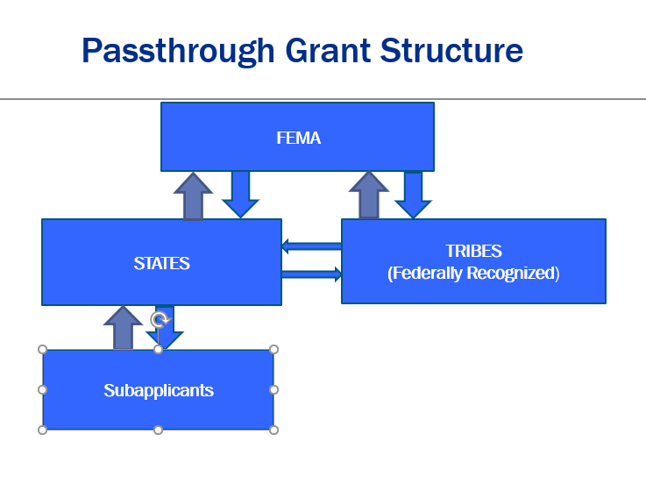

# HAZARD MITIGATION GRANT PROGRAM FUNDING TYPES

## Planning

Mitigation plans are the foundation for effective hazard mitigation. A mitigation plan is a demonstration of the commitment to reduce risks from natural hazards and serves as a strategic guide for decision makers as they commit resources.

The mitigation planning process includes hazard identification and risk assessment leading to the development of a comprehensive mitigation strategy for reducing risks to life and property. The mitigation strategy section of the plan identifies a range of specific mitigation actions and projects being considered to reduce risks to new and existing buildings and infrastructure. This section includes an action plan describing how identified mitigation activities will be prioritized, implemented and administered.

Planning activities funded under HMA are designed to develop state, tribal and local mitigation plans that meet the planning requirements outlined in 44 CFR Part 201. A mitigation planning subgrant award must either result in a mitigation plan adopted by the jurisdiction(s) and approved by FEMA, or it must result in a planning related activity approved by FEMA (e.g., incorporating new data into the risk assessment or updating the mitigation strategy to reflect current disaster recovery goals) consistent with the requirements in 44 CFR Parts 201 and 206.

For resources on HMA Planning use the HMA Guidance.

## Project

Eligible project types might include acquisition and demolition of flood-prone properties, generators for critical infrastructure, defensible space for homes in the Wildland Urban Interface or undergrounding of powerlines. More eligible project ideas are provided under Eligible Activities in this handbook. Project eligibility under HMGP can be prioritized by the state as part of the HMGP priorities developed post-disaster. For example, funding may be prioritized for projects that are related to the type of disaster. In other cases, the state may choose to prioritize on a “first come, first served” basis. Projects that do not fall under the state prioritization may still be eligible, and a pre-application should still be submitted.

## The 5% Initiative

Eligible projects can include project types that are not typically funded by FEMA hazard mitigation programs if FEMA authorizes what is referred to as the “5% Initiative.” The 5% Initiative can make funding available for new, unproven mitigation techniques and technologies where benefits are not proven or not clearly measurable. This typically means projects that are unable to show their cost effectiveness using a BCA and may include disaster-warning equipment and systems, hazard identification, mapping efforts, and studies or plans to reduce disaster losses.

## Advance Assistance

Section 1104 of the Sandy Recovery Improvement Act (SRIA) authorizes the use of Advance Assistance, which allows advancing up to 25% of the HMGP ceiling or $10 million (whichever is less) to applicants/subapplicants to accelerate the implementation of the HMGP. Applicants and subapplicants may use Advance Assistance to develop mitigation strategies and obtain data to prioritize, select and develop complete HMGP applications in a timely manner. Advance Assistance is not automatic and is included in the HMGP ceiling amount. States and federally recognized tribes may request Advance Assistance by submitting an HMGP subapplication form to the Regional Mitigation Division Director. The application must identify the proposed use of the funds, including costs in sufficient detail for each proposed activity and milestones for submitting completed HMGP subapplications to FEMA. Advance Assistance is subject to the HMGP cost-share requirements and Strategic Funds Management (SFM); FEMA will not obligate funds until the recipient/subrecipient has an immediate need for the funds. Pre-award costs are not eligible under advance assistance.

# Cost Share

The standard cost share requirements for HMGP grants are 75% federal and 25% non-federal. Federal cost share cannot exceed 75% for HMGP grants.

## What can be used for Cost Sharing?

Cash, which can be used toward:

* Staff time for project construction or management, community outreach and financial management.
* Value of land and equipment time used for a project.
* Deferred compensation for flood buyouts.
* Non-federal grants and a few federal grants (CDBG).

In-kind, sometimes known as “third party:”

* Time is an “in-kind” donation, such as volunteers.
* Professional services, materials and land.
* Careful documentation is required for in-kind cost sharing – like the Salvation Army.

A match commitment letter is required from the grant applicant and each subapplicant.

# MULTI-HAZARD MITIGATION PROJECTS

## Eligible Applicants Chart

|  |  |  |  |  |  |  |  |  |  |  |  |  |  |  |  |  |  |  |  |  |
| --- | --- | --- | --- | --- | --- | --- | --- | --- | --- | --- | --- | --- | --- | --- | --- | --- | --- | --- | --- | --- |
| |  |  |  |  | | --- | --- | --- | --- | |  | HMGP | BRIC | FMA | | State agencies | √ | √ | √ | | Tribal agencies | √ | √ | √ | | Local governments/communities | √ | √ | √ | | Private non-profit organizations (PNPs) | √ |  |  | |

## Eligible Hazard Mitigation Related Activities Includes Chart



**HINT**: Think about what natural hazard you are trying to mitigate against through a future lens.

# KEY DEFINITIONS & CONCEPTS

## Applicant/State

The state enters into a FEMA-State agreement and in doing so becomes designated as the applicant. The governor designates an Authorized Representative (GAR) who may in turn appoint alternates and subordinates to implement the various assistance programs authorized by the president. The applicant is required to develop and maintain a current FEMA-approved state standard hazard mitigation plan to receive financial assistance.

## Subapplicant

State agencies, local units of government, tribal governments, and certain nonprofit organizations qualify as subapplicants: those with FEMA-approved mitigation plans. The applicant/state, through OEM, enters into a grant agreement with subapplicants that are authorized to create the hazard mitigation plan. These grant agreements contain provisions to ensure HMGP-funded projects are undertaken in a manner that is consistent with the requirements of 44CFR§206.434 and other federal and state regulations.

## Funds Availability

Applicants should be aware that historically, the funds requested from the HMGP exceed the amount of money available. Therefore, applicants should regard the HMGP as a competitive grant. Priority is given to the affected jurisdictions and project type based on a recent disaster.

## Letter of Intent (pre-application)

Following a major disaster declaration, OEM will notify potential HMGP subapplicants of the program’s availability. In response to such a notification, potential subapplicants should prepare and submit to the applicant/state a Letter of Intent (LOI)/pre-application form.

## Sub-Grant Application (subapplication)

Upon receipt of all LOI forms, the applicant/state evaluates the subapplicant’s proposed projects against the minimum eligibility requirements established under FEMA and state guidelines. The applicant (OEM) will provide access to the HMGP subapplication packages to all eligible subapplicants that have submitted an acceptable LOI. Additionally, the applicant/state will advise all eligible subapplicants of its priorities for distributing HMGP funding.

## Cost Sharing

The total project cost, once tabulated, is divided into federal and non-federal shares. In most cases, the maximum federal share may not exceed 75% of the project’s cost. HMGP cost share is 75% federal/25% non-federal. BRIC cost share is 75% federal/25% non-federal unless a community is determined to be small and impoverished. Small and impoverished communities are allowed a 90% federal/10% non-federal cost share. If a community has fewer than 3,000 residents, is economically disadvantaged, and has an unemployment rate that exceeds by 1 percentage point or more the average national yearly unemployment rate, it is considered small and impoverished. FMA cost share varies depending on the project. Available cost shares include: 75% federal/25% non-federal, 90%/10% and 100%/0%.

## Bona Fide Need Rule

FEMA will only consider HMGP proposals that undertake work related to mitigating a legitimate, or bona fide, need. FEMA will not approve grant funding for any project that is already underway or complete before the project’s approval can be granted by FEMA. Additionally, project costs cannot be incrementally approved as a way of providing partial funding to a project already underway.

## Duplication of Programs (duplication of benefits)

HMA funds cannot duplicate funds received by or available to applicants or subapplicants from other sources for the same purpose. Examples of other sources include insurance claims, other assistance programs, legal awards, or other benefits associated with properties or damage that are subject to litigation.

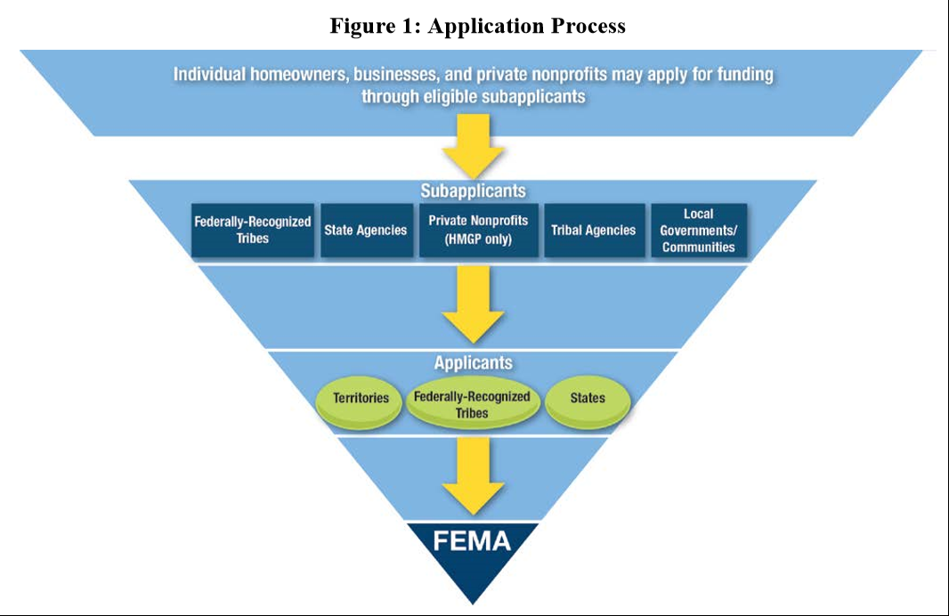

# GETTING THE SUBAPPLICANT’S PROPOSAL STARTED

Once an applicant decides to pursue an HMGP grant, a series of sequenced steps should occur.

## Subapplicant Point of Contact

The subapplicant must pick an individual to manage development of the proposal/subapplication. In many cases this individual will be an employee of the subapplicant who has knowledge of the applicant’s organizational structure, local ordinances, and is aware of the problem(s) to be addressed through hazard mitigation. The selected individual is designated the “point of contact.”

## Duties Assigned to the Subapplicant

The state helps the subapplicant through the subapplication process. Much of the information necessary to manage the subapplication’s development is included in this handbook. The subapplicant will ultimately manage development of their own HMGP proposal, including assigning tasks to others while retaining overall responsibility for the work.

## Keeping Potential Project Participants Informed

It is human nature that people impacted by unfamiliar and disruptive events will take action to restore normalcy for themselves and their families as quickly as possible. Regrettably, some people will take the wrong actions following disaster, usually because factual information and awareness of better options are not available. For this reason, it is highly encouraged that the applicant establishes a method of sharing accurate and timely information with its citizens. With regard to the HMGP, a public meeting to explain how the program might be utilized has been found to be useful. A public meeting allows people to express how their individual recovery plans are progressing and what assistance might be needed to complete the work.

This exchange of information allows a comparison between individual and community-wide goals to occur, and inconsistencies between the two to be recognized earlier rather than later. Further, it can give public officials and community leaders insight into what mitigation priorities exist and how they should be ranked. Lastly, a sign-in sheet used during the public meeting will help establish a tool for maintaining contact with people who might contribute to the planning process.

## Budget Development

Next, the subapplicant should develop a budget for the proposal. In doing so, the reviewers can determine if the proposed hazard mitigation project is comprehensive and if the resources needed to fulfill the non-federal share of the project’s cost are within the means of the applicant.

The cost estimate describes all the subapplicant’s anticipated costs associated with the Scope of Work (SOW) for the proposed mitigation activity. Cost estimates must include detailed estimates of various cost item categories such as labor, materials, equipment and subcontractor costs. **No lump-sum estimates will be accepted.** The cost estimate must identify the cost categories and value for which anticipated cash and third-party in-kind contributions will be used to meet the non-federal cost share. Subapplicants must provide an explanation and documentation demonstrating how the cost estimate was developed and the basis for each cost element, such as salary and fringe benefit rates for personnel, bids from qualified professionals, and costs established in nationally published or local cost estimating guides.

The hazard mitigation grant cost estimate must include a line-item breakdown of costs associated with all elements described in the SOW, such as:

* Application pre-award costs detailed in HMA Guidance Part 4, Section F: Pre-Award Costs.
* Project management costs.
* Architectural and engineering fees.
* Site work.
* Construction.
* Inspection fees.
* Waste disposal fees.

The table below provides an example of general pricing guidance for new plans and plan updates depending on the size of the population being served. Costs may exceed those listed in the table depending on the SOW and proposed final product (extensive mapping, new data collection, novel approach, etc.) Discussion will be necessary if the proposed costs are exceptionally higher than what is listed. **If a budget amendment is needed, the subapplicant must contact the State Hazard Mitigation Officer (SHMO) immediately prior to funds being spent.**

### Pricing Guidance for New Plans and Plan Updates Chart

|  |  |  |
| --- | --- | --- |
| Community Type | Population/RVIII Examples | Range of Costs ($) |
| Special District  Single-Jurisdictional (SJ) | Water District | $15,000-60,000 |
| Small County  Multi-Jurisdictional (MJ) | Less than 20,000 | $20,000-50,000 |
| Midsize County  Multi-Jurisdictional (MJ) | 20,000-200,000 | $40,000-70,000 |
| Midsize City  Single-Jurisdictional (SJ) | 20,000-200,000 | $20,000-80,000 |
| Urbanized County (MJ)  Metropolitan Area (MJ), or  Large City (SJ) | Greater than 200,000 | $50,000-250,000 |
| State Plan Update | Range is for RVIII States | $80,000-300,000 |

Factors affecting the range of costs:

* Technical sophistication of scope of work.
* Number and size of participating jurisdictions.
* Number of significant hazards affecting planning area.
* Variance of hazards/risk across planning area.
* Update or new plan (costs of first round updates may be similar to new plans depending on quality of original plan; second round updates should start significantly decreasing).
* Local or out-of-state planning lead/contractor.
* Post-disaster (more to analyze = higher cost).
* Economy of scale (if several similar plans are developed at once in a common area, costs go down).

### Factors that Affect the Budget – Program Income

Program income is a result of a project-related activity that generates cash or other items of monetary value. For example: a community holds a bake-off contest to raise funds for the non-federal share of the grant, using the bake-off to provide public participation and commenting on the plan. The money raised would be considered program income. Another example: federal funds are advanced and deposited in an interest-bearing bank account with the expectation that they will be used within the three days allowed by regulation. However, funds won’t be needed for one month. Unless the state directs that the funds be returned, the money will remain in the account earning interest. The amount of interest earned is considered program income.

All program income must be reported on the project’s quarterly report, and those funds should be liquidated against project commitments before any other funds are utilized.

The subapplicant will probably not be able to accurately predict program income until after the project’s approval. The subapplicant should develop a tracking system to offset and report the income. Any income earned after the grant has been closed out may reside with the subapplicant and does not have to be reported as program income.

### Pre-Award Costs

Costs incurred after the application period has opened, but prior to the date of the grant award or final approval, are identified as pre-award costs. As with project costs, all pre-award costs need to be tracked and documented as if the subapplicant had received the award. Pre-award costs directly related to developing the application are eligible costs to include in the grant budget. Such costs may have been incurred, for example, to develop a benefit cost analysis, to gather environmental clearance data, for preparing design specifications, or for workshops or meetings related to development and submission of the subapplication. Costs associated with implementation of the activity but incurred prior to grant award or final approval are not eligible (projects initiated or completed prior to grant award or full approval of the project are not eligible). To be eligible for grant funding, pre-award costs must be identified as separate line items in the cost estimate of the subapplication. Subapplicants may identify such pre-award costs as their non-federal cost share. Subapplicants who are not awarded grants will not receive reimbursement for the corresponding pre-award costs.

# Scope of Work Statement

The SOW must identify the plan or project:

* Clearly describe the intended outcome of the mitigation activity and how it will reduce risk of future damage, hardship, loss, or suffering resulting from natural disaster.
* Organize who and what is needed to complete this mitigation activity.
* Identify who will manage and oversee the project, if specific entities or contractors will be required, and what specific work activities or components will be implemented.

The SOW must describe the project or plan process:

* Describe the process for project or plan development, clearly demonstrating that applicable regulatory requirements will be met. Document in detail (including who will be responsible for completing each task) the activities and who will complete them. Describe how these activities relate to the cost estimate.
* List the major milestones in the proposed project, beginning with the kickoff meeting after award and ending with the closeout process.
* Provide an estimated time frame for the completion of each milestone; this should be in the form of number of months needed for completion.
* The Period of Performance (POP) for HMGP grants is limited to and may not exceed 36 months.

The SOW must describe the Hazard Mitigation Plan requirements:

* State, tribal and local jurisdictions, with the exception of private nonprofit organizations, must have or be included in a FEMA-approved HMP to receive funding through the HMGP.
* The state, tribal or local jurisdiction must have a FEMA-approved HMP at the time of award and the project must be in some way included in the state and local plan.
* Private nonprofit organizations do not need to meet the Hazard Mitigation Planning requirement, but they must have proper certification and the project must be in some way included in the state’s plan.
* An “Extraordinary Circumstances Exception” may be granted if approved by the state and FEMA prior to award.

Completing the HMGP application:

* The final step for this phase is to complete the HMGP subapplication. The applicant/state will provide the format for the subapplication and will also provide federal and state assurance documents required at the time of submission.
* The subapplicant should pay particular attention to the deadline established by the applicant/state for submission of the HMGP subapplication. At the time of submission to FEMA, the subapplication will be designated a unique identification number.

# Environmental Historic Preservation (EHP)

The integrity of the natural and historic landscape is important, and steps taken to strengthen or rebuild communities can have long-term environmental and cultural impacts. Environmental Planning and Historic Preservation (EHP) is not just a desirable outcome of community projects—it’s a legal requirement. Federal law requires that most projects funded through a FEMA grant program comply with EHP requirements.

While some FEMA grant applications require minimal EHP review, others demand more attention due to the nature of the project proposed. For example, work to a historic building or construction of a flood control structure near endangered species’ habitats can understandably have a significant impact on cultural and environmental resources and involve more extensive review. Other activities that trigger more in-depth EHP review may not be as obvious—such as projects involving construction on undeveloped land or modifications to structures more than 45 years old. By collaborating with EHP early in the planning and grants process, subapplicants can get a clear indication of the potential impacts of projects on natural and cultural resources and minimize the possibility of lengthy review.

Subapplicants and communities can play a critical role in helping FEMA expedite the review process. The earlier communities begin project planning and the more information subapplicants provide in the project description, the better equipped FEMA will be to help subapplicants anticipate and address any legal requirements that may affect a project.

# MANAGING HMGP SUBAPPLICATIONS – PRE-APPROVAL

The applicant/state will conduct a completeness review of all HMGP subapplications submitted by the deadline and may, based upon its findings, notify the subapplicant that additional information or clarification of certain data may be necessary. The subapplicant should be prepared to respond to requests from FEMA, sometimes sent via the applicant/state, for additional information that may be needed to complete the National Environmental Protection Agency (NEPA) review.

After the HMGP proposal is reviewed by the applicant/state, the subapplicant may be asked to perform any or all the following actions:

* Refine the proposal (i.e. expand the problem statement to elaborate on some “ripple effect” issue, clarify some detail included in the proposed solution, revise the budget to keep estimated costs close to the proposal’s anticipated benefits, etc.).
* Request for Information (RFI) from FEMA or OEM.
* Provide additional studies as deemed appropriate.

While waiting for notification from FEMA for an HMGP award, the subapplicant may wish to get ready to manage the grant. Some recommended steps include:

* Ensure record and bookkeeping systems are ready.
* Draft contracts, purchase orders, grant management procedures, etc.
* Keep participants informed about the status of the proposal.
* Keep stakeholders and members of the media on your side.
* Remain in contact with the grantee and notify the office of any change.

In anticipation of approval of the proposal, the subapplicant may wish to begin tracking its in-kind contract work and force account contributions.

# MANAGING AN APPROVED HMGP PROJECT

## The Applicant (OEM) notifies Subapplicant of HMGP Proposals Approval by FEMA

Included in the FEMA approval will be a letter indicating the following:

* Name of the project and National Emergency Management Information System (NEMIS) project ID number.
* Date of approval.
* Approved SOW.
* Approved POP.
* Approved budget amount.
* Quarterly reporting requirements.

## Application for Federal Assistance, Grant Agreement and Certifications

The applicant/state will contact the subapplicant and arrange to implement the HMGP project though a kickoff meeting. This meeting may be in person or conducted remotely and attended by the subapplicant, OEM HMGP and OEM fiscal representatives.

## Fiscal Requirements

Federal HMGP funds are awarded to cover the federal share of all direct project costs. The remaining non-federal share must be matched from the source(s) indicated in the applicant’s proposal. Funds are only provided on a reimbursement basis. Cash advances are not a standard practice for the grantee. The only circumstance where the grantee may advance funds is to acquire those real properties scheduled for closing within 30 days of the request for funds. Therefore, if your community does not have the financial resources to cover payments before receiving grant funds, you may want to plan ahead when it comes to scheduling closings or paying invoices.

Access to these funds will be through a Request for Reimbursement (RFR) form (format to be supplied by the grantee during the kickoff meeting). The RFR form must be accompanied by supporting documentation showing expense(s) for which reimbursement is being sought. The SHMO and grant accountant review all pay requests and documentation before processing payment. From that point, each request generally takes 10-15 days before funds are deposited electronically into the applicant’s account. In the event the subgrantee does not have electronic funds transfer (EFT) capabilities, a paper check (state warrant) will be issued and mailed to the subgrantee’s business address.

### Procedures for Completing and Submitting an RFR Form

* The subapplicant prepares and submits a full or partial payment request for allowable costs outlined in the grant agreement and the FEMA approved SOW.
* The RFR form will specify the FEMA project number, the project title, the name of the subgrantee and contact information, and date of the request.
* Additionally, the RFR will outline the funds being requested based on both the budget line item and the non-federal cost share for each expense.

## Rounding to Whole Dollar

The federal government uses only whole dollar amounts when awarding the total project cost, which includes federal and non-federal shares. Therefore, the project application should also be prepared using a whole dollar amount system. Under this system, each claimed expense is listed by approved budget line item and divided according to the authorized federal and non-federal cost shares.

Tabulations for requests for reimbursement are evaluated line-by-line rather than by the total 100% amount being requested for reimbursement. Any line amount division resulting in fractional federal or non-federal amounts will be rounded to the nearest two decimal places. The result of the rounded federal and non-federal amounts should add up to the 100% costs being requested for reimbursement.

## Certification and Authorization

This part of the form is self-explanatory; however, if the Letter of Credit Payment Request is not signed by the subapplicant, the Chief Executive Officer, Chief Finance Officer or Fiscal approver, the request cannot be processed and will be returned.

## Scope of Work

The approved SOW represents what information has been submitted, reviewed and approved in the project. FEMA’s approval letter will identify whether the plan will be funded. Only the activities on the approval letter will be eligible for project inclusion. The SOW will also include details on budget line items and if conditions exist that may affect continuance of the work.

In the event the subapplicant discovers that the approved SOW needs to be modified, the subapplicant will notify the applicant/state of the need for a change in writing. A change of scope is not guaranteed and the subapplicant should take all reasonable and necessary steps to limit or stop further project work until approval of the change has been granted by FEMA.

## Activation of Subapplicant Project Support Systems

The subapplicant should next activate all the systems that were developed for support of the project. This includes drawing cash from the designated general or special account to open the project account, releasing advertisements for bid of design services, and notifying the project participants that the project is approved.

## Bidding Out Work

The subapplicant must have written procedures that cover all procurement actions that must, at a minimum, comply with federal requirements as stated by 44 CFR, Part 13.36. When procuring goods and/or services, the subapplicant’s agent must use a fair and competitive process conducted pursuant to the applicable regulations and procedures outlined below:

* In arranging for professional services, buyers are required to follow the procurement standards established by the Oregon Department of Administrative Services (DAS). Local established procurement policies are allowed if they are more stringent than state and federal regulations.
* All purchases are required to be made as prescribed in the appropriate state laws and 2 CFR, 200.317-200.326 and the requirements of 2 CFR, Part 200, Appendix II, Required Contract Clauses.
* “Cost plus percentage of cost” or “percentage of construction cost” contracting is prohibited and contract methodologies using the same are not allowed.
* To avoid awarding a contract to barred contractors, the subgrantee must conduct reasonable research into the background of bidders and subcontractors before entering into a purchase agreement or contract.

## Cost Over Runs and Under Runs

It is understood that the project’s budget was based on best available information, but it was still developed through an estimation process. Therefore, it is important for the subapplicant to identify when the project’s overall budget or specific budget categories have too little or too much money. The funds needed to cover cost over runs should come from the approved project first by way of moving funding from one budget category to another.

When the approved project is able to restructure its budget to meet the requirement, the subapplicant can wait until its next quarterly report filing to notify the applicant/state of the change. However, when the subapplicant is unable to restructure its obligations to accommodate the cost over run, the subapplicant must immediately notify the SHMO or deputy of the situation and not incur any additional financial obligations. The applicant/state may have a small amount of reserve funds available to deal with over runs. If no reserve funds are available, the applicant/state can examine other approved projects to determine if a cost under run might exist, and if so, it can request from FEMA a de-obligation of funds from the donor project and a supplemental obligation of funds to the deficient project.

The obligation of funds to cover cost over runs cannot be guaranteed since the HMGP is formula based and federal subscriptions may not exceed the applicant’s total award.

## Quarterly Reporting

Subrecipients are required to submit quarterly progress reports that provide sufficient detail to measure progress of the funded project.

The following reporting periods and due dates apply:

**Reporting Period** **Report Due Date**

January 1 to March 31 April 15

April 1 to June 30 July 15

July 1 to September 30 October 15

October 1 to December 31 January 15

# PROJECT CLOSEOUT

## Closeout Request

Once all approved mitigation actions are complete and all issues connected with same are extinguished, the subapplicant may request formal project closeout from the applicant. The closeout request must be in writing and the following supporting documentation must be attached. A list of the grant-specific closeout documents will be provided by the OEM, but here are a few of the standard required documents:

* Final request for reimbursement.
* Final quarterly progress reports.
* Final performance and expenditure report.
* Equipment inventory forms with accompanying photos (if applicable).
* Copy of any plans developed with grant funding (if applicable).
* **Before, during, and** after/final site inspection and site photos including latitude and longitude, brief narrative, date of photo, and which phase the photo represents (if applicable).
* Deed restriction (if applicable).

## Record Retention

The subapplicant is required to maintain project documentation for at least six years after the project’s “official” completion. In this case, “official” means after all work is complete, all bills are paid, any non-expendable property is reconciled, all audit requirements (including Single Audit Act reporting) have been satisfied, and the applicant and FEMA agree that the project is complete. Property-related projects must be kept indefinitely (i.e. property acquisition/demolition). Project files with records that contain Personally Identifiable Information (PII) are covered under the Privacy Act of 1975 (5 U.S.C. §522A, as amended). The subapplicant must maintain confidentially of all PII records and can only release the records in accordance with the disclosure rules outlined in the act. Further, the subapplicant must document all disclosures of PII information and reset the three-year record retention schedule to reflect the day of disclosure as the first day. These records are usually retained at the local level in accordance with local requirements.

## Single Audit Act

Any time a non-federal entity expends $750,000 in federal grant awards in a single fiscal year, it is required to obtain an annual audit in accordance with the Single Audit Act Amendments of 1996 (2 CFR 200.500). The Single Audit Act review will incorporate review elements included in Office of Management and Budget (OMB) Circulars A-87, A-102, A-110 and A-133 (to include the current year’s compliance supplement).

Additional information about the Single Audit Act may be found online at: <https://www.whitehouse.gov/wp-content/uploads/2020/08/2020-Compliance-Supplement_FINAL_08.06.20.pdf>

The cost of conducting an audit in compliance with the Single Audit Act is eligible for project reimbursement so long as the project award alone is $750,000 or more and no other federal grant is in excess of the reporting threshold; or if the project award contributes 50% or more of the combined federal grants that equal or exceed $750,000. If another federal award greater than the HMGP award exists, the cost for a Single Audit Act report will not be eligible.

## Grant Compliance

During the kickoff meeting, the SHMO will review the grant award, certifications and quarterly reporting.

Subapplicants are responsible for complying with all rules and regulations of the grant. Areas to watch include:

* Standard and consistent reporting.
* Adhering to any restrictions outlined in the Finding of No Significant Impact (FONSI) or other environmental/historical studies.
* Ensuring work is conducted during appropriate times outlined in the grant agreement letter.
* Notifying the SHMO or their deputy of any changes to scope of work, financial status, or grant progress.
* Notifying the SHMO or their deputy to coordinate any POP, SOW or quarterly reporting extensions.

Failure to comply with the regulations and requests identified in the grant agreement could make the subapplicant ineligible for further funding or deobligation of funds by OEM.

OEM will have regional representatives assisting with compliance with monitoring of HMGP grants.

# ELIGIBLE ACTIVITIES

## Property Acquisition and Structure Demolition

The voluntary acquisition of an existing flood prone structure, and typically, the underlying land, and conversion of the land to open space through the demolition of the structure. The property must be deed-restricted in perpetuity to open space uses to restore and/or conserve the natural floodplain functions.

## Property Acquisition and Structure Relocation

The voluntary physical relocation of an existing structure to an area outside of a hazard-prone area, such as the Special Flood Hazard Area (SFHA) or a regulatory erosion zone, and typically, the acquisition of the underlying land. Relocation must conform to all applicable state and local regulations. The property must be deed-restricted in perpetuity to open space uses to restore and/or conserve the natural floodplain functions.

## Structure Elevation

Physically raising and/or retrofitting an existing structure in accordance with ASCE 24-14 (Base Flood Elevation [BFE] plus freeboard) or higher when required by FEMA or local ordinance. Elevation may be achieved through a variety of methods, including elevating on continuous foundation walls; elevating on open foundations, such as piles, piers, posts or columns; and elevating on fill. Foundations must be designed to properly address all loads and be appropriately connected to the floor structure above, and utilities must be properly elevated as well. FEMA requires recipients and subrecipients to design all structure elevation projects in accordance with ASCE 24-14.

## Mitigation Reconstruction

The construction of an improved, elevated building on the same site where an existing building and/or foundation has been partially or completely demolished or destroyed. Mitigation reconstruction is only permitted for structures outside of the regulatory floodway or coastal high hazard area (zone V) as identified by the existing best available flood hazard data. Activities that result in the construction of new living space at or above the BFE will only be considered when consistent with mitigation reconstruction requirements. FEMA requires recipients and subrecipients to design all mitigation reconstruction projects in accordance with ASCE 24-14.

## Dry Floodproofing

Techniques applied to keep structures dry by sealing the structure to keep floodwaters out. FEMA requires recipients and subrecipients to design all dry floodproofing projects in accordance with ASCE 24-14. Dry floodproofing is not permitted in zone V. Generators are emergency equipment that provide a secondary source of power. Generators and related equipment (e.g., hookups) are eligible provided they are cost effective, contribute to a long-term solution to the problem they are intended to address, and meet other program eligibility criteria. A generator that is a stand-alone project can be considered under regular HMGP funding if the generator protects a critical facility. Critical facilities may include police and fire stations, hospitals and water and sewer treatment facilities (for the definition of critical facilities, see Appendix B, Glossary). A generator that is a component of a larger project (e.g., elevation of a lift station) can also be funded under regular HMGP funding and the use of aggregation is permitted. Stand-alone generator projects that cannot be determined to be cost effective via standard HMA benefit-cost methodology may be eligible under the 5% Initiative.

## Localized Flood Risk Reduction Projects

Projects to lessen the frequency or severity of flooding, and decrease predicted flood damage, within an isolated and confined drainage or catchment area that is not hydraulically linked or connected to a larger basin. These projects include, but are not limited to, installation or modification of culverts and other stormwater management facilities; construction or modification of retention and detention basins; and construction or HMA Guidance – modification of floodwalls, dams, and weirs. Modifications must be for the purpose of increasing risk reduction capabilities of the existing structures and cannot constitute only repairs. Localized flood risk reduction projects must not duplicate the flood prevention activities of other federal agencies and may not constitute a section of a larger flood control system.

## Non-localized Flood Risk Reduction Projects

Projects that lessen the frequency or severity of flooding, and decrease predicted flood damage, within an area that is hydraulically linked or connected to a drainage basin that is regional in scale. These projects reduce flood hazards in areas larger than that of localized flood reduction projects and may include the construction, demolition or rehabilitation of dams; construction or modification of dikes, levees, floodwalls, seawalls, groins, jetties, breakwaters and stabilized sand dunes; and large-scale channelization of a waterway. Modifications must be for the purpose of increasing risk reduction capabilities of the existing structures and cannot constitute only repairs. These projects cannot constitute a section of a larger flood control system or duplicate the flood prevention activities of other federal agencies on the same site.

## Structural Retrofitting of Existing Buildings

Modifications to the structural elements of a building to reduce or eliminate the risk of future damage and to protect inhabitants. The structural elements of a building that are essential to prevent damage include foundations, loadbearing walls, beams, columns, building envelope, structural floors and roofs, and the connections between these elements.

## Nonstructural Retrofitting of Existing Buildings and Facilities

Modifications to the nonstructural elements of a building or facility to reduce or eliminate the risk of future damage and to protect inhabitants. Nonstructural retrofits may include bracing of building contents to prevent earthquake damage or the elevation of utilities.

## Safe Room Construction

Safe room construction projects are designed to provide immediate life-safety protection for people in public and private structures from tornado and severe wind events, including hurricanes. For HMA, the term “safe room” only applies to extreme wind (combined tornado and hurricane) residential, non-residential and community safe rooms; tornado community safe rooms; and hurricane community safe rooms. This type of project includes retrofits of existing facilities or new safe room construction projects and applies to both single and dual-use facilities.

## Wind Retrofit Projects

Wind retrofit projects of one- and two-family residential buildings must be designed in conformance with the design criteria found in FEMA P-804, Wind Retrofit Guide for Residential Buildings (2010). Infrastructure Retrofit: Measures to reduce risk to existing utility systems, roads, and bridges.

## Soil Stabilization

Projects to reduce risk to structures or infrastructure from erosion and landslides, including installing geotextiles, stabilizing sod, installing vegetative buffer strips, preserving mature vegetation, decreasing slope angles, and stabilizing with rip rap and other means of slope anchoring. These projects must not duplicate the activities of other federal agencies.

## Wildfire Mitigation

Projects to mitigate at-risk structures and associated loss of life from the threat of future wildfire through:

### Creation of Defensible Space

Projects creating perimeters around homes, structures, and critical facilities through the removal or reduction of flammable vegetation.

### Application of Ignition-resistant Construction

Projects that apply ignition-resistant techniques and/or non-combustible materials on new and existing homes, structures and critical facilities.

### Hazardous Fuels Reduction

Projects that remove vegetative fuels proximate to at-risk structures that, if ignited, pose a significant threat to human life and property, especially critical facilities.

## Post-Disaster Code Enforcement

Projects designed to support the post-disaster rebuilding effort by ensuring that sufficient expertise is on hand to guarantee appropriate codes and standards, including NFIP local ordinance requirements, are used and enforced.

## 5% Initiative Projects

These projects, which are only available pursuant to an HMGP disaster, provide an opportunity to fund mitigation actions that are consistent with the goals and objectives of the state or tribal (standard or enhanced) and local mitigation plans and meet all HMGP requirements, but for which it may be difficult to conduct a standard BCA to prove cost effectiveness.

# INELIGIBLE ACTIVITIES

## HMA Grant Funds May NOT be Used for the Following Costs/Items:

* Costs incurred against the federal share PRIOR to notification of the grant award.
* Projects that do not reduce the risk to people, structures or infrastructure.
* Projects that are dependent on a contingent action to be effective and/or feasible (i.e., not a stand-alone mitigation project that solves a problem independently or constitutes a functional portion of a solution).
* Projects with the sole purpose of open space acquisition of unimproved land.
* Property acquisition projects that are not compatible with open space and do not maintain open space for the conservation of natural floodplain functions, or properties that include encumbrances that may allow for horizontal drilling or fracking.
* Non-localized flood risk reduction projects specific to FMA.
* Flood control projects related to the repair or replacement of dams and other flood control structures, and repair of dams for the purpose of regular prescheduled or damage-induced maintenance.
* Projects for which actual physical work, such as groundbreaking, demolition, or construction of a raised foundation, has occurred prior to award or final approval. Projects for which demolition and debris removal related to structures proposed for acquisition or mitigation reconstruction has already occurred may be eligible when such activities were initiated or completed under the FEMA Public Assistance (PA) program to alleviate a health or safety hazard as a result of a disaster.
* Projects for preparedness activities or temporary measures (e.g., sandbags, bladders, geotubes).
* Projects that create revolving loan funds.
* Activities required due to negligence or intentional actions that contributed to the conditions to be mitigated; activities intended to remedy a code violation; or the reimbursement of legal obligations, such as those imposed by a legal settlement, court order or state law.
* All projects located in Coastal Barrier Resources System (CBRS) Units, other than property acquisition and structure demolition, or relocation projects for open space under HMA. For details on CBRS Units see Addendum, Part A.6.
* Projects located in an Otherwise Protected Area (OPA) that require flood insurance after project completion.
* Activities on federal lands or associated with facilities owned by another federal entity.
* Projects related to beach nourishment or renourishment.
* Projects for hazardous fuels reduction in excess of two miles from at-risk buildings and structures.
* Projects that address unmet needs from a disaster that are not related to mitigation.
* Retrofitting facilities primarily used for religious purposes, such as places of worship (or other projects that solely benefit religious organizations). However, a place of worship may be included in a property acquisition and structure demolition or relocation project provided that the project benefits the entire community, such as when a significant part of the community is being removed from the hazard area.
* Activities that only address man-made hazards.
* Projects that address, without an increase in the level of protection, the operation, deferred or future maintenance, rehabilitation, restoration or replacement of existing structures, facilities or infrastructure (e.g., dredging, debris removal, replacement of obsolete utility systems or bridges, maintenance/rehabilitation of facilities, including dams and other flood control structures).
* Projects for the purpose of:
  1. Landscaping for ornamentation (e.g., trees, shrubs).
  2. Site remediation of hazardous materials (with the exception eligible activities, such as the abatement of asbestos and/or lead-based paint and the removal of household hazardous wastes for disposal at an approved landfill).
  3. Water quality infrastructure.
  4. Projects that primarily address ecological or agricultural issues.
  5. Forest management.
  6. Prescribed burning or clear-cutting.
  7. Creation and maintenance of fire breaks, access roads or staging areas.
  8. Irrigation systems.
* Studies not directly related to the design and implementation of a proposed mitigation project.
* Preparedness measures and response equipment (e.g., response training, electronic evacuation road signs, interoperable communications equipment).

# HMGP Forms and Examples

## Pre-Application Form/Letter of Intent

**Hazard Mitigation Assistance**

**Pre-Application Form/Letter of Intent**

Submitting this form ensures that your proposal is reviewed by the Mitigation Team. This document is the first step in the grant subapplication process. By submitting this form alone, it **does not guarantee funding**. To be considered for the grant funding, complete this form and submit it to [shmo@mil.state.or.us](mailto:shmo@mil.state.or.us). This form will also be used for the Interagency Hazard Mitigation Team (IHMT) review panel if/when activated for appliable grant program/grant round (shaded boxes to the right are for official use only for scoring/ranking pre-applications).

# A. Hazard Mitigation Assistance Grant Programs

Select the grant program you are seeking funding under *(select one)*:

**Pre-Disaster (Annual):** Building Resilient Infrastructure and Communities (BRIC)

**Pre-Disaster (Annual):** Flood Mitigation Assistance (FMA)

**Post-Disaster:** Hazard Mitigation Grant Program (HMGP): Click here to enter text.

**Post-Disaster:** Hazard Mitigation Grant Program (HMGP) Post Fire(PF): Click here to enter text.

**B. Activity Type**

Select the applicable activity type you are pursuing *(select all that apply)*:

|  |  |  |
| --- | --- | --- |
| **BRIC** | **FMA** | **HMGP and HMGP-PF** |
| Capability- and Capacity-Building | Project Scoping | Advance Assistance |
| Project Scoping | Community Flood Mitigation Project | Plan |
| Building Codes | Flood Hazard Mitigation Planning | Project |
| Partnerships | Individual Flood Mitigation Project | 5 Percent Initiative |
| Planning | Technical Assistance |  |
| Mitigation Project |  |
| Technical Assistance |  |  |

|  |
| --- |
|  |

# C. Subapplicant Information

1. County or Tribal Land your entity is based in: Please specify

2. Select the type of entity you fall under that is seeking HMA funding *(select one):*

State Government  Tribal Government

Local Government  Private Nonprofit (PNP)

Special District  Other Please specify

3. Subapplicant: Click here to enter text.

Point of Contact Name and Job Title: Click here to enter text.

Phone Number: Click here to enter text. E-mail Address: Click here to enter text.

Street Address: Click here to enter text.

City: Click here to enter text. State: Click here to enter text. Zip: Click here to enter text.

# 

# D. Mitigation Plan

1. Identify which FEMA-approved hazard mitigation plan your entity is included in below.

Plan Name: Click here to enter text. Expiration Date: Click here to enter a date.

|  |
| --- |
|  |

2. If this is **a proposal for a planning-related activity**, please identify Plan Type you will be pursuing funding for *(select one)*:

State Hazard Mitigation Plan ☐ Tribal Hazard Mitigation Plan

Local Hazard Mitigation Plan ☐ Tribal (Local) Hazard Mitigation Plan

Local Multijurisdictional Hazard Mitigation Plan ☐ Tribal (Local) Multijurisdictional Hazard Mitigation Plan

☐ Never had a Hazard Mitigation Plan ☐ Other planning-related activity: Please specify

**E. Proposal**

Proposal Title: Click here to enter text.

Estimated Overall/Total Cost: $Click here to enter text.

Do you anticipate a non-federal cost share exceeding 25%?

|  |  |  |  |  |
| --- | --- | --- | --- | --- |
| Yes | No | Unsure |  |  |

If yes, please provide a brief narrative and estimated percentage your jurisdiction intends on putting forth for the local cost share/match: Click here to enter text.

Estimated Local Management Cost (is up to 5% of the amount listed above): $Click here to enter text.

Brief Proposal Description: Click here to enter text.

# F. Community Lifelines

|  |  |
| --- | --- |
| Select all applicable community lifelines that your proposal will reduce risk to: |  |

**Safety and Security** (law enforcement/security, fire services, search and rescue, government services, and community safety)

**Food, Water, Shelter** (food, water, shelter, agriculture)

**Health and Medical** (medical care, patient movement, public health, fatality management, medical supply chain)

**Energy** (power (grid) and fuel)

**Communications** (infrastructure, alerts, warnings, and messages, 911 and dispatch, responder communications, finance)

**Transportation** (highway, roadway, motor vehicle, mass transit, railway, aviation, maritime)

**Hazardous Martial** (facilities, HAZMAT, pollutants, contaminants)

**Not Applicable**

**G. Natural Hazards**

|  |  |
| --- | --- |
| Select all applicable natural hazards that your proposal will reduce/mitigate the risk of: |  |

|  |  |  |
| --- | --- | --- |
| Coastal Erosion | Heat Wave | Wildfire |
| Drought | Landslide | Windstorm |
| Earthquake | Tsunami | Winter Storm |
| Flood | Volcano | Other: Please specify |
|  |  |  |

**H. Climate Change**

Will this proposal enhance climate change adaptation and resilience?

*Climate change is defined as “Changes in average weather conditions that persist over multiple decades or longer. Climate change encompasses both increases and decreases in temperature, as well as shifts in precipitation, changing risk of certain types of severe weather events, and changes to other features of the climate system.”*

|  |  |  |  |  |
| --- | --- | --- | --- | --- |
| Yes | No | Unsure | Not Applicable |  |

If yes, please provide brief description how your proposal will enhance climate change adaptation and resilience: Click here to enter text.

**I. National Floodplain Insurance Program (NFIP)**

Does this proposal involve mitigating a National Floodplain Insurance Program (NFIP) property?

*The National Flood Insurance Program (NFIP) aims to reduce the impact of flooding on private and public structures. It does so by encouraging communities to adopt and enforce floodplain management regulations. In exchange, flood insurance is made available to property owners and renters. These efforts help mitigate the effects of flooding on new and improved structures.*

|  |  |  |  |  |
| --- | --- | --- | --- | --- |
| Yes | No | Unsure | Not Applicable |  |

If yes, please provide further information regarding the property (is the property in a Special Flood Hazard Area, is it considered a Severe Repetitive Loss Property or a Repetitive Loss Property, etc.): Click here to enter text.

**J. Community**

|  |  |  |  |
| --- | --- | --- | --- |
| Select all items listed below that are applicable to the community that the proposal will benefit: | | |  |
| Limited water and sanitation access and affordability | High unemployment and underemployment | High housing cost burden and substandard housing | |
| High and/or persistent poverty | Low income | Limited access to health care | |
| Rural community | Linguistic isolation | Distressed neighborhoods | |
| Jobs lost through the energy transition | Disproportionate impacts from climate | All geographic areas within Tribal jurisdictions | |
| High energy cost burden and low energy access | High transportation cost burden and/or low transportation access | Disproportionate environmental stressor burden and high cumulative impacts | |
| Racial and ethnic segregation particularly where the segregation stems from discrimination by government entities | Not Applicable |  | |

**K. Additional Information**

**1. Is this an infrastructure project?**

*Infrastructure is defined as critical physical structures, facilities, and systems that provide support to a functioning community, its population, and its economy.*

|  |  |  |  |  |
| --- | --- | --- | --- | --- |
| Yes | No | Unsure | Not Applicable |  |

If yes, please provide further information regarding what type of infrastructure: Click here to enter text.

**2. Does this project incorporate nature-based solutions?**

*Nature-based solutions are sustainable planning, design, environmental management, and engineering practices that weave natural features or processes into the built environment to promote adaptation and resilience. Such solutions enlist natural features and processes in efforts to combat climate change, reduce flood risks, improve water quality, protect coastal property, restore and protect wetlands, stabilize shorelines, reduce urban heat, add recreational space, and more.*

|  |  |  |  |  |
| --- | --- | --- | --- | --- |
| Yes | No | Unsure | Not Applicable |  |

If yes, please describe how it will incorporate nature-based solutions: Click here to enter text.

**3. Does your entity have Building Code Effectiveness Grading Schedule (BCEGS) Rating of 1 to 5?**

*The Building Code Effectiveness Grading Schedule (BCEGS®) assesses the building codes in effect in a particular community and how the community enforces its building codes, with special emphasis on mitigation of losses from natural hazards. For more information regarding this question, please go to* [*https://www.isomitigation.com/bcegs/*](https://www.isomitigation.com/bcegs/)*.*

|  |  |  |  |  |
| --- | --- | --- | --- | --- |
| Yes | No | Unsure | Not Applicable |  |

If yes, please provide more information regarding your rating:

**4. Is this proposal from a previous FEMA HMA advance assistance or project scoping award, High Hazard Potential Dams (HHPD) award, or DHS Cybersecurity and Infrastructure Security Agency’s (CISA) Regional Resiliency Assessment Program (RRAP), or a previous recipient of BRIC non-financial Direct Technical Assistance?**

|  |  |  |  |  |
| --- | --- | --- | --- | --- |
| Yes | No | Unsure | Not Applicable |  |

If yes, please identify which award and brief description: Click here to enter text.

**5. Does this proposal increase resilience and reduce risk of injuries, loss of life, and damage and destruction of property, including critical services, and facilities?**

|  |  |  |  |  |
| --- | --- | --- | --- | --- |
| Yes | No | Unsure | Not Applicable |  |

If yes, please briefly describe how the project will effectively reduce risk and increase resilience, realize benefits, and leverage innovation. Potential benefits could include how this project will address inequities and provide the greatest support to those with greatest need: Click here to enter text.

**6. Will this proposal utilize innovative techniques to facilitate implementation?**

|  |  |  |  |  |
| --- | --- | --- | --- | --- |
| Yes | No | Unsure | Not Applicable |  |

If yes, please provide brief description on how you intend to implement this proposal: Click here to enter text.

**7. Will this proposal include an outreach strategy?**

|  |  |  |  |  |
| --- | --- | --- | --- | --- |
| Yes | No | Unsure | Not Applicable |  |

If yes, please provide brief description how your proposal will enhance climate change adaptation and resilience: Click here to enter text.

**8. Will your entity be incorporating any partnerships** **(e.g., state, tribal, private, local community, etc.)** **that will ensure the proposal meets community needs, including those of disadvantaged populations?**

|  |  |  |  |  |
| --- | --- | --- | --- | --- |
| Yes | No | Unsure | Not Applicable |  |

If yes, please provide brief description how your proposal will incorporate partnerships and what is the anticipated outcome of those partnerships (e.g., leveraging resources such as financial, material, and educational resources, coordinating multi-jurisdictional projects, heightened focus on equity related issues, etc.): Click here to enter text.

**\*\*\*\*\*\*\*\*\*\*\*\*\*\*\*\*\*\*\*\*\*\*\*\*\*\*\*\*\*\*\*\*\*\*\*\*\*\*\*\*\*\*\*\*\*\*\*\*\*\*\*\*\*\*\*\*\*\*\*\*\*\*\*\*\*\*\*\*\*\*\*\*\*\*\*\*\*\*\*\*\*\*\*\*\*\*\*\*\*\*\*\*\*\*\*\*\*\*\*\*\*\*\*\*\*\*\*\*\*\*\*\*\*\*\*\*\*\*\*\*\*\*\*\*\*\***

***(For official use only)***

|  |  |  |  |  |
| --- | --- | --- | --- | --- |
|  |  |  | ***Total Pre-application Score:*** |  |

## Example SOW for a Planning Grant

Planning Grant Example Scope of Work

### Purpose

The [insert name of local community(ies)] will develop a local hazard mitigation plan [indicate whether plan is an *update*] to reduce potential losses from future disasters. The plan will meet the federal mitigation planning requirements of 44 CFR 201.6 to be eligible to apply for project grants under FEMA’s Hazard Mitigation Assistance programs.

This will be a [indicate single jurisdiction or multi-jurisdictional] plan. [If multi- jurisdictional plan, include: The jurisdictions represented in the plan include: [list jurisdictions]. See attached statements of intent to participate in the project.] The [insert lead agency] will coordinate this planning project. The project will result in a FEMA-approved local hazard mitigation plan that will be aligned with the [insert name of approved State Mitigation Plan].

### Plan Development Tasks

The proposed planning project has five tasks:

**Task 1.** Organize planning team and conduct outreach activities.

**Task 2.** Document the planning process.

**Task 3.** Conduct a risk assessment.

**Task 4.** Develop a mitigation strategy.

**Task 5.** Submit and adopt the plan.

### Task 1. Organize Planning Team and Conduct Outreach Activities

The [insert lead agency] will establish a planning team to oversee the development of the plan. The planning team will include representation from each participating jurisdiction. The planning team will identify and involve stakeholders in the planning process, including local and regional agencies involved in hazard mitigation activities; agencies that have the authority to regulate development; neighboring communities; and other public, private and non-profit interests. The planning team will identify and conduct activities that involve all the participating jurisdictions to provide an opportunity for the public to participate in the plan’s development.

### Task 2. Document the Planning Process

The plan will document the planning process used to develop the plan and detail how the plan will be maintained within a five-year cycle, including the following information:

* Presenting how it was prepared, including who was involved in the process and how.
* Identifying the public that was involved.
* Detailing how each jurisdiction participated in the plan’s development.
* Explaining how plans, studies, reports and technical information were reviewed and incorporated.
* Demonstrating how each jurisdiction will continue public participation and monitor, evaluate and update the plan within a five-year cycle.

### Task 3. Conduct a Risk Assessment

The plan will include a risk assessment developed by the planning team that includes the following:

* Description of the natural hazards that can affect the jurisdictions in the planning area, including each hazard’s type, location, extent, previous occurrences and probability of future events.
* Summary of the potential impacts of each hazard in each jurisdiction.
* Description of the types and numbers of NFIP insured structures within each jurisdiction that have been damaged by floods.
* An overall summary of the vulnerabilities of each jurisdiction.
* Assessment of the capabilities, including the authorities, policies, programs, and resources available to accomplish hazard mitigation of each jurisdiction.

The updated plan will include an assessment of the changes in development in hazard-prone areas and how the vulnerability of each jurisdiction has been affected. The updated plan will also include hazard events that have occurred and any other appropriate changes in data and analysis since the last plan was developed.

### Task 4. Develop a Mitigation Strategy

Each jurisdiction will participate in the development of a mitigation strategy that reflects the results of the risk assessment and includes the following:

* Overall goals for reducing risk in the planning area.
* Specific mitigation actions and projects being considered to reduce the impacts identified in the risk assessment, with an emphasis on new and existing buildings and infrastructure for each jurisdiction.
* Description of each jurisdiction’s participation in the NFIP and continued compliance with NFIP requirements, as appropriate.
* Description of how the mitigation actions identified will be prioritized, implemented and administered by each jurisdiction.
* A process for how the mitigation strategy will be implemented into other planning mechanisms in each jurisdiction.

The updated plan will include an evaluation of the status of the hazard mitigation actions in the previous plan and describe the progress made in achieving goals and implementing actions. The planning team will revise the plan’s priorities to reflect current conditions. The updated plan will describe how each jurisdiction incorporated the mitigation plan into other planning mechanisms as a demonstration of progress.

### Task 5. Submit and Adopt the Plan

The [insert lead agency] will submit the final draft plan in digital copy and the FEMA Local Mitigation Plan Review Tool completed with page numbers of required elements to the [insert name of state agency] for initial review. If available, the subapplication also should include a copy of the crosswalk or Local Mitigation Plan Review Tool from the FEMA approval of the previous plan. The subapplicant will provide the state with a list of mitigation capabilities and actions as directed for inclusion in the state HMP database.

The state will forward the plan to FEMA Region VIII for review and conditional approval pending local adoption. Revisions to the plan will be made as required by the state and FEMA. After this review is completed and pending approval given, the plan will be formally adopted by the [insert name of decision-making body(s) of each jurisdiction]. Resolutions of adoption will be provided to the state and FEMA for final plan approval.

### Attachments

Attachments for a Planning HMGP Grant may include (not inclusive):

* County floodplain maps.
* Geographical map with jurisdiction boundaries marked.
* Risk factors page from previous plan.
* Jurisdiction information.
* Matrixes (these or other created ones).
* Other documentation, such as a letter on county letterhead that each jurisdiction has signed stating they will participate fully in the planning process (this will make a stronger application).

### Project/Plan Period of Performance (POP)

The amount of time necessary to undertake and complete the applicant’s proposal should be documented in terms of months necessary to complete the project. While it is not necessary to outline every step the applicant will take, key activities should be assigned an expected completion period in order to monitor the progress of the project.

From time of project approval, there are three timelines that may be appropriate, depending on whether the plan is an update or a brand-new plan. Justification for any of the proposed timelines will be required with the subapplication. There are additional tasks listed in the sample schedules not included in the plan development section.

Subapplications should include a work schedule for all project tasks identified in the SOW. There will be three months at the beginning and end of the POP to account for state/FEMA contracting and approval, as well as compliance and review closeout.

The schedule should identify timeframes for accomplishing significant milestones. For planning subapplications, it is critical that the work schedule allow sufficient time for state and FEMA reviews; preparation of required revisions, if needed; formal adoption by the jurisdiction(s); and FEMA approval.

The following tables are examples of nine-, 12- and 15-month POPs. The tasks included are broken down further than what is necessary for the cost/budget in the subapplication but may help with budget development. The tasks listed can be compressed into four categories: management costs/meetings; data gathering/mapping; hazard and risk assessment; and plan writing and editing.

### Sample Timeline 9 Month POP

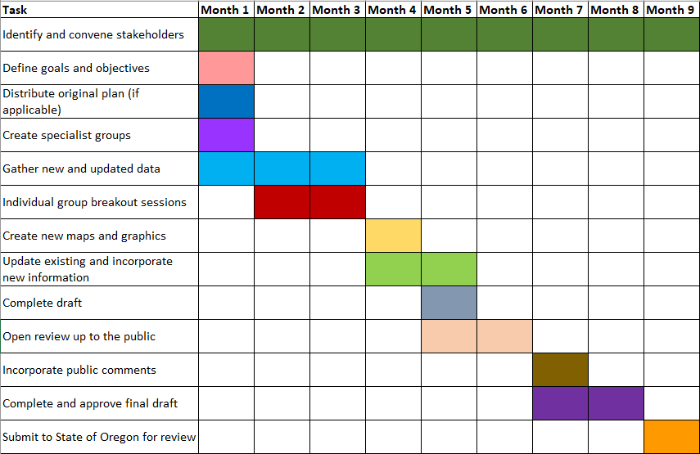

### Sample Timeline 12 Month POP

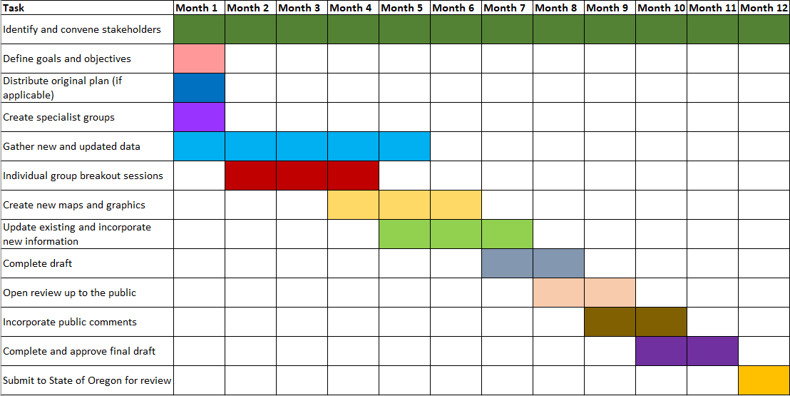

### Sample Timeline 15 Month POP

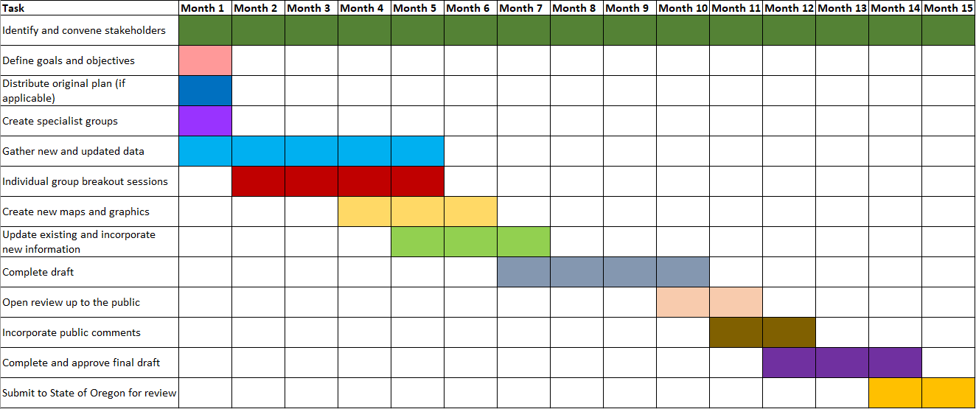

### Completing the HMGP Application

The final step for this phase is to complete the HMGP application. The applicant/state will provide the format for the subapplication and will also provide federal and state assurance documents required at the time of submission.

The subapplicant should pay particular attention to the deadline established by the applicant/state for submission of the HMGP application. At the time of submission to FEMA, the subapplication will be designated a unique identification number.

## Example Advance Assistance Pre-Application/Letter of Intent

**Advance Assistance LOI Example**

1. **Subapplicant Name:** City of Townton
2. **AA Project Title:** Defensible Space Project Development
3. **Project Type:** Advance Assistance
4. **Project Cost Estimate:** $200,000
5. **Project Summary (750 words or less):**

The City of Townton has many properties located in the Wildland Urban Interface. Each year, wildfire becomes more of a threat to our citizens and their homes. The City of Townton Natural Hazard Mitigation Plan lists defensible space measures for our community as a high priority. We are requesting Advanced Assistance Funding to 1. Assess the properties within our town that need defensible space; 2. Speak to landowners to determine which are willing to participate in defensible space measures; 3. Document and estimate the costs to implement the defensible space measures; 4. Create a benefit cost analysis to ensure the project is viable; and 5. Complete a subapplication that we can submit for HMGP funding.